Universität Bern

Introduction to Software Engineering

Shoppyapp

Software Requirements Specification Document

v0.1

02.10.2013

Customer  
Mircea Lungu

Technical Tutor  
Andrei Chis

Autors  
Sammer Puran / Lukas Galliker / Marc Schneiter / Sébastien Broggi

Introduction 1

Purpose 1

Stakeholders 1

System overview 2

References 2

Overall description 3

Use case diagram 3

Use cases 4

|  |  |  |
| --- | --- | --- |
| Version | Date | Revision Description |
| 1 | 02.10.2013 | First version of the document. |
|  |  |  |
|  |  |  |
|  |  |  |
|  |  |  |

# Introduction

## Purpose

Shoppy is an application for the Android platform to manage shopping lists with the phone. The main purpose of Shoppy is managing your shopping lists and the ability to organize them together with your friends.

The goal of this application is to be a time-saver and cooperative tool to organize shopping with your friends and family.

## Stakeholders

The application is of use for anybody who likes to create a list before going shopping to not forget what he or she likes to buy. In that sense most people are potential customers of Shoppy. As we plan our initial release of the App only for the Android plattform, just owners of an Android driven phones can use our application.

To make the potential amount of users a bit more visible, we include some statistics for mobile plattform market shares.

Mobile/Tablet Operating System Market Share as of September, 2013

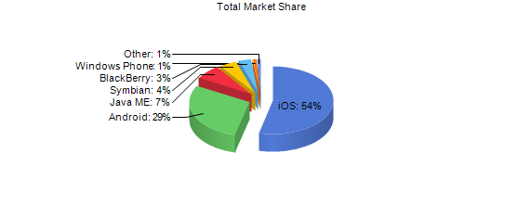

Source: http://www.netmarketshare.com/

These numbers are difficult to evaluate and differ significantly depending on what source is used, but they can give an impression of the mobile market.

## System overview

The suggested name of the application is Shoppy which is a short and easy to rememer name and has a sympathetic and cute subtone.

The user can create multiple shopping lists for different purposes and share each of them with other people. All users of a shopping list can add, remove and edit items from shopping lists, mark them as bought and organize them in categories. All of these actions will be syncronized in case of a shared list. A shared list can be created by selecting people from the phone contacts.

If the user starts typing in a new item for a list, the applications suggests items that were already added to a list in the past

When you open the app it returns to the last opened list and presents you the items you have to buy.

## References

There are a lot of already existing shopping list applications, but each of them has different downsides. We evaulated user comments for many apps and tried to build our feature set with these comments in mind. Some very popular applications are:

* [Out of Milk](https://play.google.com/store/apps/details?id=com.capigami.outofmilk)
* [Einkaufsliste](https://play.google.com/store/apps/details?id=com.DramaProductions.Einkaufen5)
* [myShopi](https://play.google.com/store/apps/details?id=com.agilys.myshopi)

# Overall description

## Use case diagram

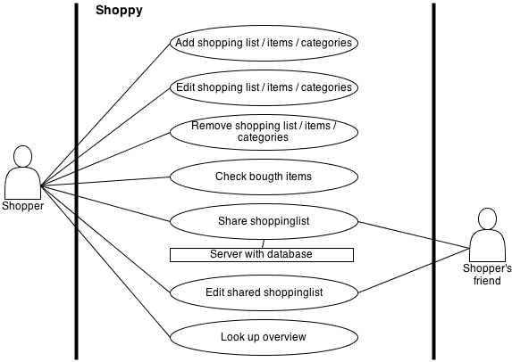

## Use cases

1. Add Shopping List:
   1. Actors
      1. Customer
   2. Description
      1. As a customer I want to add a shopping list, name it and want to see it.
   3. Trigger
      1. By clicking the add button.
   4. Pre-conditions
      1. The customer has to have bought the app.
   5. Post-conditions
      1. A new shopping list has been created.
   6. Main Scenario
      1. Customer opens the app.
      2. Customer presses the “add” Button.
      3. Customer can view the newly created list.
   7. Alternative Scenarios
      1. Add by importing a list from a friend (sharing).
         1. Customer buys the app.
         2. Customer opens the app.
         3. Customer imports an already existing list from a friend.
   8. Special Requirements
      1. None
   9. Notes
      1. You cannot name a list the same as an existing list. It gives an error and you can’t create such a list.

1. Edit Shopping List:
   1. Actors
      1. Customer
   2. Description
      1. As a customer I want to rename already existing shopping list or the items in the shopping list
   3. Trigger
      1. By clicking on the edit button after selecting a list.
   4. Pre-conditions
      1. There exists already a (or more than one) shopping list and a Shopping List is selected
   5. Post-conditions
      1. The shopping list is succesfull renamed
   6. Main Scenario
      1. 2.) Customer opens the app
      2. 3) Customer selects a list
      3. 4) Customer clicks on the edit/rename button
      4. 5) Customer enters a new name for the shopping list
      5. 6.) Customer saves the changes (by clicking on the save button)
   7. Alternative Scenarios
      1. None
   8. Special Requirements
      1. None
   9. Notes
      1. Customer cannot rename the list the same as an existing list. He will be asked to chose another name.

1. Add Item to Shopping List:
   1. Actors
      1. Customer
   2. Description
      1. As a customer I want to add items to an already existing Shopping List
   3. Trigger
      1. By clicking on the Add  Item Button after selecting a Shopping List
   4. Pre-conditions
      1. There exists already a (or more than one) Shopping List and a Shopping List is selected
   5. Post-conditions
      1. The item is added to the Shopping List
   6. Main Scenario
      1. 2.) Customer opens the app
      2. 3) Customer selects a list (he navigates to the point where he wished to add the item)
      3. 4) Customer clicks on the add button
      4. 5) Customer enters a name for the item
      5. 6.) Customer saves the changes (by clicking on the save button)
   7. Alternative Scenarios
      1. None
   8. Special Requirements
      1. None
   9. Notes
      1. None
2. Use Shopping List
   1. Actors
      1. Customer
   2. Description
      1. The Customer should be able to actually use the list he created while shopping and check the items he bought. This can be done by pressing a Checkbox (temporary)
   3. Trigger
      1. User starts shopping and uses the app to see the items he wants to buy.
   4. Pre-conditions
      1. There has to be a list the Customer can use.
   5. Post-conditions
      1. The Customer should have checked all the items he has bought.
   6. Main Scenario
      1. Customer enters shop
      2. Customer starts app
      3. Customer chooses list
      4. Customer starts shopping
   7. Alternative Scenarios
      1. None
   8. Special Requirements
      1. None
   9. Notes
      1. Main feature - Definitely implemented
3. Share Shopping List
   1. Actors
      1. Customer
      2. Shopping Friend
   2. Description
      1. A customer wants to share his shopping list with his friends, which he can access through a share option. After sharing, the Customer who shares his list should be the admin of it and controls the actions of the other friends he shared it with. As a user i also want to stop sharing a list.
   3. Trigger
      1. Customer chooses a list and shares it.
   4. Pre-conditions
      1. The Customer has to have a list to share. The friend either has to have the App, or recieves a link to download it.
   5. Post-conditions
      1. The friend of the Customer should see the list and be able to edit it
   6. Main Scenario
      1. Customer starts app
      2. Customer chooses a list
      3. Customer shares list
   7. Alternative Scenarios
      1. None
   8. Special Requirements
      1. None
   9. Notes
      1. How should sharing exactly be implemented?
4. Edit shared Shopping List
   1. Actors
      1. Customer
   2. Description
      1. The Customer can edit lists shared with him
   3. Trigger
      1. User edits a list shared with him
   4. Pre-conditions
      1. The user has a list shared with him
   5. Post-conditions
      1. The list should be changed, and is then synced with the original one.
   6. Main Scenario
      1. Customer starts app
      2. Customer choses shared list
      3. Customer edits shared list
   7. Alternative Scenarios
      1. None
   8. Special Requirements
      1. None
   9. Notes
5. Overview of Items
   1. Actors
      1. Customer
   2. Description
      1. The Customer can view all the items he has bought or still has to buy from a list
   3. Trigger
      1. The Customer chooses a List he wants to read.
   4. Pre-conditions
      1. The Items have been added, so they can be viewed. If there are no Items in a List, nothing is showed.
   5. Post-conditions
      1. The customer knows what he still has to buy and what he already bought.
   6. Main Scenario
      1. Customer starts the app
      2. Customer chooses a List he wants to view
      3. Customer reads the Items
   7. Alternative Scenarios
      1. None
   8. Special Requirements
      1. None
   9. Notes
6. Remove Item from Shopping List
   1. Actors
      1. Customer
   2. Description
      1. As an User I want to remove item from a shopping List
   3. Trigger
      1. After selecting a shopping list and a item, which the user wants to remove, the user clicks on the remove button to remove items
   4. Pre-conditions
      1. There exists a shopping list which is selected: The shopping list contains of one or more than one item.
   5. Post-conditions
      1. The item is removed
   6. Main Scenario
      1. 2. Customer opens the app.
      2. 3. Customer selects a Shopping List (he navigates to the point where he wants to delete the item)
      3. 4. Customer selects an item, which he chooses to remove
      4. 5. Customer clicks on remove button
      5. (6.Customer confirms that he wants to remove this item )
      6. 7.Customer saves changes by clicking on the save button
   7. Alternative Scenarios
      1. None
   8. Special Requirements
      1. None
   9. Notes
      1. Customer can’t delete items on an empty shopping list. Remove button doesn’t work on an empty shopping list
7. Add Categories
   1. Actors
      1. Customer
   2. Description
      1. As an user I want to add categories to a shopping list or to an item.
   3. Trigger
      1. By clicking on the Add Categories Button after selecting either a list or an item
   4. Pre-conditions
      1. There exists a list or an item which is selected
   5. Post-conditions
      1. The categorie is added to the list/item
   6. Main Scenario
      1. 2. Customer opens the app.
      2. 3. Customer selects a Shopping List
      3. (4. Customer selects an item in the Shopping List)
      4. 5. Customer clicks on add category button
      5. 6.Customer names the category
   7. Alternative Scenarios
      1. Special Requirements
   8. Notes
      1. Couldn’t we just have a add item Button and the customer himself chooses how to arrange his items and if he wants to arrange his items in categories? Can be discussed.
8. Edit Items
   1. Actors
      1. Customer
   2. Description
      1. As an user I want to edit (that means rename) existing items.
   3. Trigger
      1. By clicking the edit button after selecting the corresponding item
   4. Pre-conditions
      1. There exists a shoppping list and there exists an (or more than one) item in it.
   5. Post-conditions
      1. The item is edited
   6. Main Scenario
      1. 1. Customer buys the app.
      2. 2. Customer opens the app.
      3. 3. Customer selects a Shopping List
      4. 5. Customer selects the item, which he wishes to edit
      5. 6.Customer clicks on the edit button
      6. 7. Customer renames the item
      7. 8.Customer saves the changes by clicking the save button
   7. Alternative scenarios
      1. None
   8. Special requirements
      1. None
   9. Notes
      1. The customer cannot rename the item after an already existing item. If he does so he will be asked to choose another name.

Functional requirements

all use cases

Non-functional requirements (external, performance, etc.)

Sharing via push notifications

excellent performance! (app has to be started or provided with a shopping-list screen almost instantly, overall performance should not be annoying (for example the scrolling is continuous, the transitions between different pages is fluid)